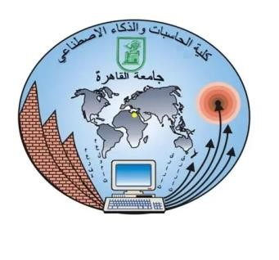
Cairo University the Faculty of Computers and Artificial
Intelligence

Instructor : Neamat El Tazi
Course Name : Web Technology
Course Number :IS231
Level: Second level – FCAI 2024-2028

Project Number : 15 Project Name : Online Library

Names: | IDs: | Section: | TA:
Moamen Mohamed Saied | 20240621 | 19 | Aliaa
Muhammed Hussein Ahmed | 20242279 | 19 | Aliaa
Muhammed Sherif Abd El-Rahim | 20242288 | 19 | Aliaa
Seif El-Din Samir | 20242177 | 19 | Aliaa
Ali Sami Mohamed | 20240344 | 19 | Aliaa

GitHub Links: https://github.com/mohamed4-5/Online-Library.git

